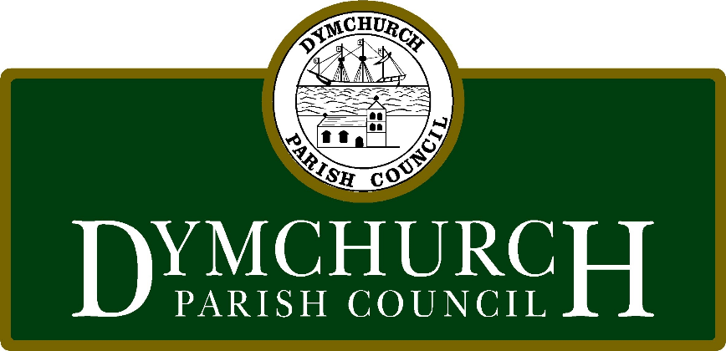

Dymchurch Parish Council

Fire Safety Plan

October 2023
Office Details & Contact Numbers

Office Address: 13 Orgarswick Ave, Dymchurch, Kent TN29 0NX
Emergency Contact Numbers: Jeff Lawrence 07972 418565
Adrian Lawson 07982 775453
Ashe Alarms 01303 872821
Clerk: Jeff Lawrence 07972 418565

Introduction
This plan is designed to ensure the safety of all employees and visitors in the event of s fire emergency in compliance with UK fire safety regulations. Please familiarise yourself with both the plan and the designated assembly area.

Office Layout
Front Office
Hallway
Meeting Chamber
Toilet
Rear Hallway

Emergency Equipment
Fire Extinguishers are located in the hallway. (CO2 and Water)
Emergency Exit Signs are located in the hallway above the doors in the meeting chamber and above fire exits.
Smoke Detectors are located in the front office and meeting chamber.

Evacuation Procedure
On discovering a fire or hearing the smoke alarm:
Alert any other people in the building

Determine your nearest exit route:
Exit doors are in the hallway to the front of the building and rear hallway at the back.

Assist Others:
Help any colleagues or visitors who may need assistance.

Evacuate the Building:
Leave all personal belongings behind
Close doors behind you to help contain the fire

Assemble at the designated area:
Proceed across the road to the BT telephone exchange
The Clerk will ensure everyone is present and accounted for
Call 999

Do not re-enter the building:
Until the “all clear” is given by the emergency services

Keep Exit Routes clear at all times:
Report any damaged or missing fire equipment to the clerk

This fire evacuation plan is intended to protect the lives and well being of everyone in the office and is compliant with UK fire safety regulations. Please take it seriously and be prepared to act swiftly and safely in the event of an emergency

